STATIC LIBRARY ---- ASSIGNMENT

1. Create 3 files as below.

· libapplication.c – will contain main() and will invoke functions in cal_utility.c

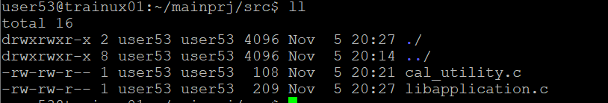

· cal_utility.c – will contain atleast 2 or more functions [ You may add definitions of the functions in this file ]

2. Refer the steps for shared library and create a shared library comprising of cal_utility.c,.h files

3. Create an executable using shared library.

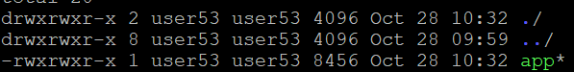

4. Execute the application created step 3

